User Guide 42 User Authentication Levels and Document Authentication in SPEAR
Purpose of this User Guide
The purpose of this User Guide is to outline the differences between the SPEAR authentication levels (user specific), and the way documents are authenticated/approved in SPEAR.
Who should read this?
Primary audience: All SPEAR users
Introduction
SPEAR is an application that enables Subdivision Act plans to be electronically submitted to the Responsible Authority, referred to referral authorities and tracked online from the initial planning stage through to certification and issuing of Statement of Compliance (SOC). As such, the main components of SPEAR are only accessible to surveyors (Applicant Contact), Responsible Authorities, referral authorities, Land Use Victoria and public objectors.
In SPEAR most documents/decisions that are attached must be finalised (approved).
This approval is called ‘authentication’ and is used to ensure that a suitably authorised SPEAR user has checked/approved the documents and decisions that have been attached by their organisation to a SPEAR application.
It is important to note that any document/decision which has been attached in SPEAR requiring authentication will not be visible to other user groups until it has been authenticated.
Authentication Levels in SPEAR
There are five authentication levels in SPEAR which determine the extent of a user’s authority to authenticate (approve) documents and decisions.
These authentication levels are defined for each user by their Local Administrator and are linked directly to a user name (login).
The key authentication levels in SPEAR are:
- Standard
- One Click
- Password Approval
- Delegate Approval
- Signing
Most documents or decisions in SPEAR will require authentication. If this is the case, then those documents or decisions will be flagged with an action to authenticate.
The required authentication for each document will be shown in the authentication prompt on the Details tab:
- ‘Authenticate – Click’
- ‘Authenticate – Password’
- ‘Authenticate – Delegate’
- ‘Authenticate – Sign’
If a user does not have the required authentication level, the prompts shown above will be ‘greyed out’ for that user. Someone else, with a higher authentication level in the organisation will need to login to SPEAR to authenticate those documents/decision.
Other SPEAR users within the same organisation can be notified to authenticate documents and decisions if required.
A user can see their own authentication level, under their name in the blue SPEAR banner. A user’s authentication level can be modified by the Local Administrator at an organisation.
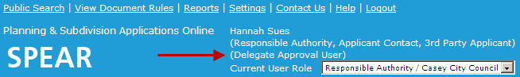

Documents and decisions can be authenticated based on a user’s authentication level as follows:
 |  | Document/decisions: authentication requirement
 |  | View, attach and modify  Authentication not required | Authenticate - Click | Authenticate - Password | Authenticate - Delegate | Authenticate – Sign  Digital Signing Certificate Required
User Authentication Level | Standard |  | N/A | N/A | N/A | N/A
 | One Click |  |  | N/A | N/A | N/A
 | Password |  |  |  | N/A | N/A
 | Delegate |  |  |  |  | N/A
 | Signing
Not all organisations have the same authentication level options to assign to their users:
 |  | Organisation Authentication Levels
 |  | Applicant Contact | Responsible Authority | Referral Authority | Land Victoria | VCAT
User Authentication Level | Standard
 | One Click |  |  |  | N/A
 | Password |  |  |  | N/A
 | Delegate | N/A |  | N/A | N/A | N/A
 | Signing |  |  | N/A | N/A | N/A

How to Authenticate documents and decisions in SPEAR
‘Authenticate – Click’
- Ensure ‘Authenticate – Click’ is displayed in the drop-down box alongside the document in the Details tab and select 'go'.
- A confirmation message will be displayed confirming authentication of the document.
- The status of the document changes from ‘Not Authenticated’ to ‘Supplied’.

‘Authenticate – Password / Delegate’
- Ensure ‘Authenticate – Password’ or ‘Authenticate – Delegate’ is displayed in the drop-down box alongside the document in the Details tab and select 'go'.
- At the password prompt, key in your SPEAR login password, and click ‘authenticate’.
- A confirmation message will be displayed confirming authentication of the document.
- The status of the document changes from ‘Not Authenticated’ to ‘Supplied’.

‘Authenticate – Sign’
Users who have an authentication level of ‘Sign’ will also require a digital certificate to complete the ‘Authenticate – Sign’ action.
- Ensure that ‘Authenticate – Sign’ is displayed in the drop-down box alongside the document in the Details tab and select 'go'. The Sign Document screen will be displayed, select the items you wish to sign and click 'sign'. A download link will appear, click the downloaded ‘.signing’ file to launch the signing application.
- A pop-up box will appear which identifies your digital certificate details. Click 'Sign'.
- A password box will appear. Type in your digital certificate password and click 'OK'.
- A confirmation message will be displayed confirming authentication of the document.
- The status of the document changes from ‘Not Authenticated’ to ‘Digitally Signed’.
Digitally signed documents will be watermarked with the evidence of signing. For example, following the authentication (signing) of a plan of subdivision, the plan will display the following line of text in the lower margin of every page:
Signed by: <Licensed Surveyor> (Applicant Contact Organisation) Surveyor's Plan Version (#) <Date>

Multiple Authentications:
If there is a list of documents that require authentication, it is possible to authenticate them all at the same time.
- Select 'go' alongside one of the documents that requires authentication.
- All documents requiring authentication will be displayed. Tick the documents you wish to authenticate and click 'Authenticate Selected Document'.
- SPEAR will prompt you to password authenticate the relevant documents, and then digitally sign the remaining documents as per the process defined above for each authentication type.
- A confirmation message will be displayed confirming successful authentication of the selected documents.
- The status of the documents will change from ‘Not Authenticated’ to ‘Supplied’ (or ‘digitally signed’).

‘Notify for Authentication’
- From the Details screen, select the ‘Notify for Authentication’ option in the drop-down list and click 'go'.
- The Notify to Authenticate screen will be displayed. Select a user to authenticate the document.
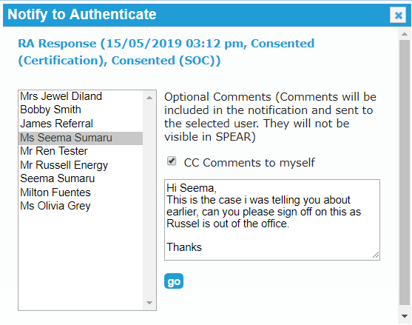

- You can leave a comment for the selected user with any information you feel relevant to the case and then click ‘go’.
NOTE: Comments will not be stored within the SPEAR system.

- You will be returned to the Details tab with a message at the top of the screen indicating the request was forwarded to the relevant user.

Need more information?
Further information on this topic can be found by:
- Visiting the SPEAR website www.spear.land.vic.gov.au/SPEAR
- Contacting the SPEAR Service Desk on 9194 0612 or email spear.info@delwp.vic.gov.au

